Membership
The annual subscription is £15 for Individual Members and £25 for Joint (two individuals).
Individual Life Membership is £150 and £200 for a Joint Membership
Application Form for Membership
o Individual Member o Individual Life Member
o Joint Member o Joint Life Member
Name(s) …………………………………………….
Address …...
……………………………………………… ……………………………………………..
…………………………………………….
Post Code ……………………………………...
Telephone……………………………………………
email…………………………………………………
I enclose remittance /Bankers Order for £…………………………..
If you wish you can Gift Aid your donation provided you pay an amount of income or capital gains tax at least equal to the amount the Friends will claim
(25p per £1.00).
Please tick the box if you are able to enhance your donation in this way.
Signature……………………………………………
Date ………………………………………………..

Banker’s Order
To : The Bank Manager of………………………. .
………………………………………………Bank plc
Address ………………………………………………
………………………………………………………
……………..…………………………………………
Please pay to :
HSBC Bank plc
Market Square
Penrith CA11 7SN
Sort Code 40-26-06
For the account of Newlands PCC Friends Account 61428047
The sum of £ ……………..
Monthly / Quarterly/ Annually (delete as appropriate)
Commencing on ….…../…….…/………. And until further notice by me.
To the debit of my account.
Name ………………………………………………
Account Number …………………………………
Signed ……………………………………………..
Date …../……../……..

Please send completed form to:
Hon Treasurer (Friends of Newlands Church)
Greystones, Braithwaite, Cumbria, CA12 5SZ
Friends of
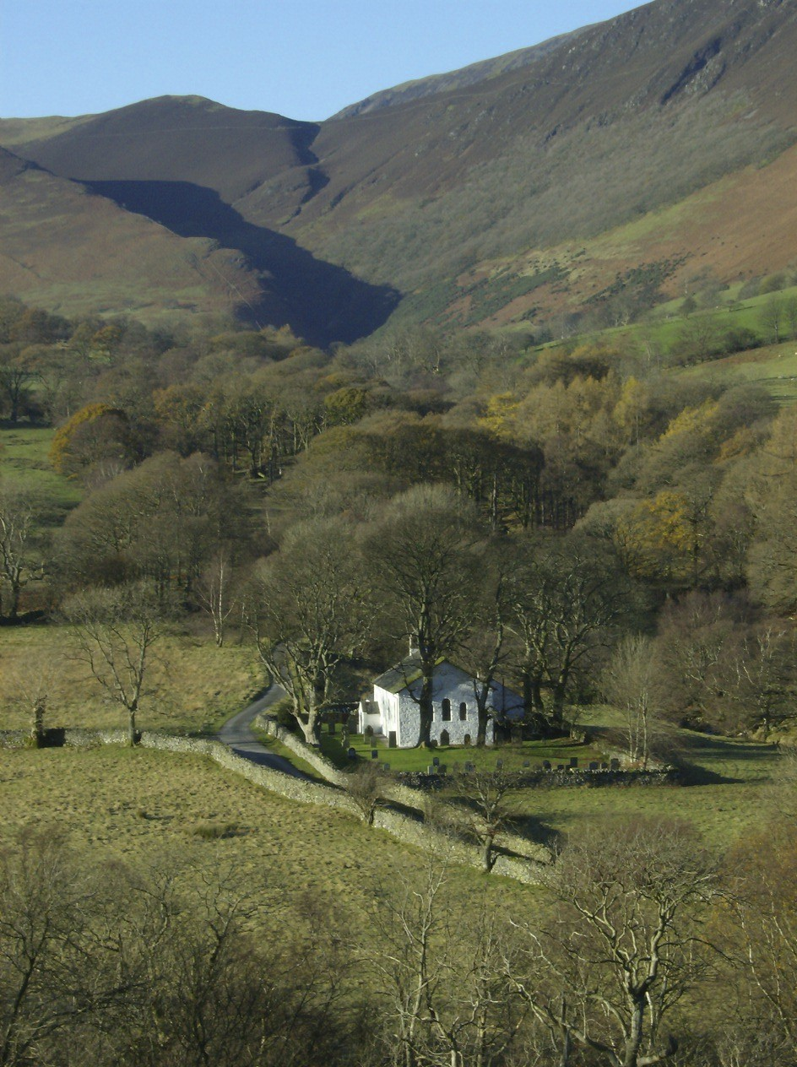
Newlands Church

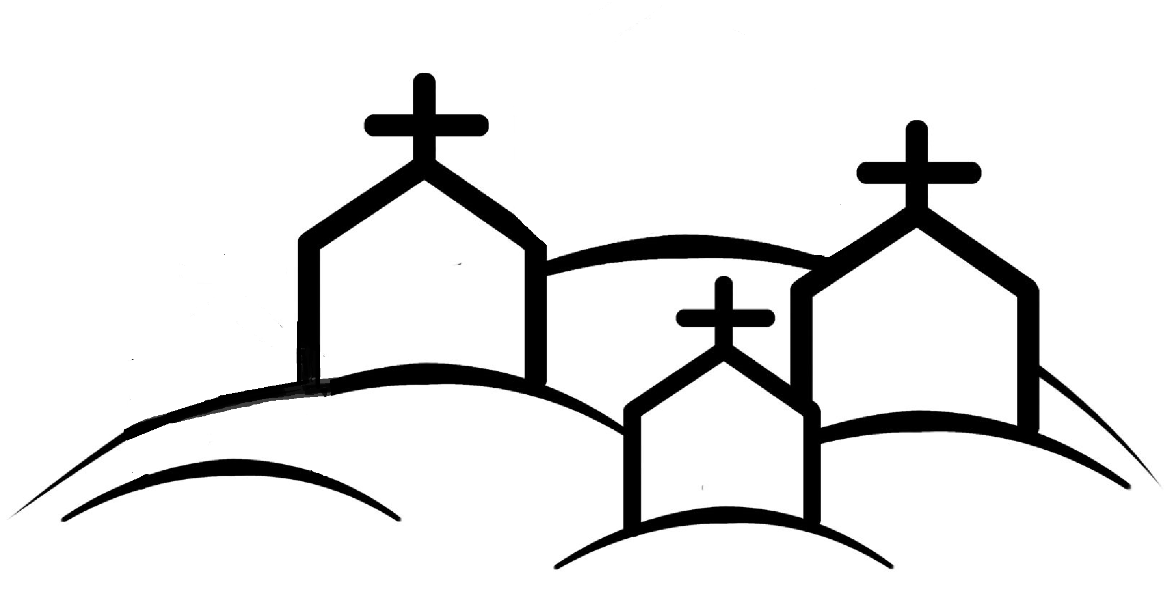
Join today and help us preserve this unique church

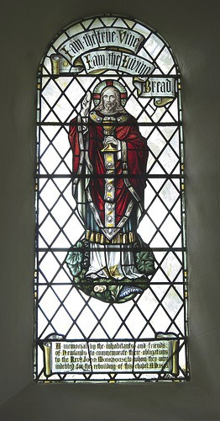
We believe that the Newlands Valley wouldn’t be the same without the Church and feel sure that visitors would agree and would want to help ensure its continuing presence for future generations

Why do we need your help ?

We endeavour to meet our day to day costs from within the local worshipping and wider community, but we also need to be able to meet the larger non regular maintenance costs as and when they arise. Our architectural inspection in 2017 estimates that we will need to incur costs of some £30,000 over the next five years to maintain the church in a satisfactory condition.

What can you do ?

By joining the ‘Friends of Newlands Church’ you will be contributing to meeting these costs and assisting in securing its future by keeping the fabric of the building in good condition.

We will keep you up to date by sending an annual Newsletter.
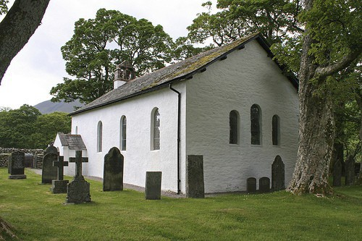

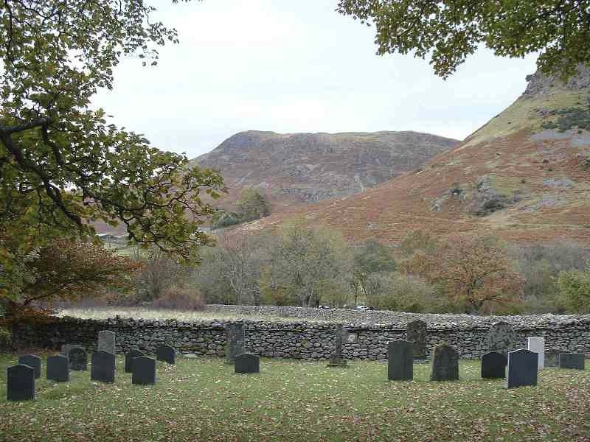
The exact date of the origin of Newlands Church is not known but there is reference to a chapel on this site in the mid 16th Century.

By the early part of the 1840s the church was in a rundown state and John Monkhouse who became Curate in 1840 took up the task of raising funds for rebuilding

A few years later an adjoining school was added. This remained open until 1967.

In 1885 further major internal refurbishment took place, and this is substantially the building as it remains today

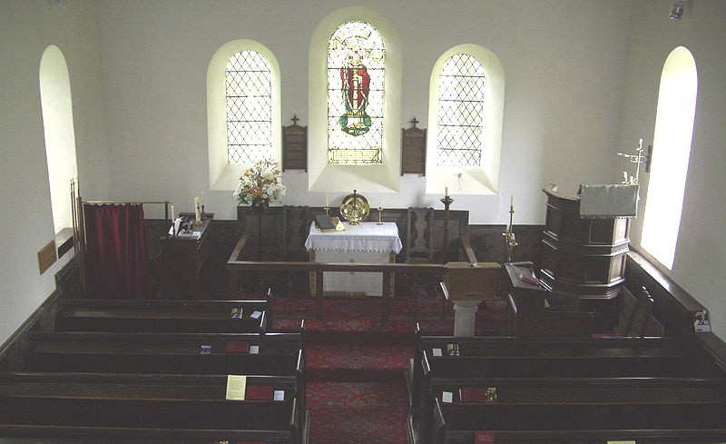
The church is open during the day and many walkers and other visitors call to take in the unique atmosphere.
The church is available for weddings and other special services and the school room (with kitchen and w.c.) can be hired for small group meetings (e.g. walkers, artists, photographers).

